LOK JAGRUTI KENDRA UNIVERSITY
M.Sc. Cybersecurity Semester III
Class Test
Subject Code:340110315 Date: 27/10/2026
Subject Name: Ethical Hacking & Penetration Testing
Duration: 01:00 Hour Total Marks: 10

NOTE: All the Practical’s are compulsory
- Mention Set number & Enrollment number in the answer sheet (If not written or wrong set number is written then answer sheet will not be evaluated and marked zero.)
- Also, only if the answers are correct then and then marks will be given
- Make sure no other documents apart from the necessary documents (which require during exam) for the exam should be open (If open then liable for the UFM)
- For the Viva, if student can’t answer the question, then 0 marks will be given by the invigilator/ viva taker.
- During exam, if student finds doing any copy paste from any document or taking help from the online medium then answer won’t be accepted and will get 0 marks for the whole exam (UFM)
- Students can write down the analysis according to the steps, make sure steps include technical words only (If not then marks will be given accordingly).
- Also Screen Shot should be appropriate as per the steps and important things must be highlighted in the Screenshot with the Timestamps (If not then marks will be given accordingly)
- Most Importantly, screenshots without proper visibility of timestamps will not be considered and the student can be liable to get 0 marks.
- If any students have just mentioned the Steps without appropriate Screenshots, then the question gets 0 marks.
- If the Browser history Screenshot before and after the exam is not there then marks will be deducted accordingly.
- Answer sheet will only be accepted in the google classroom submission (If students fail to submit on time due to any reason, they will get 0 marks)

ANSWER SHEET
Practical: 01

AIM: Perform a SQLi on DVWA. DVWA security - low. Crack the hashes received via JohntheRipper or HashCat tools. Mention 5 prevention and mitigration on the SQLi attack and what should an Ethical Hacker should do. make a report including evidence and According to CVSS 3.1 mention the Score.

Procedure

Step 1: Check Metasploitable connectivity on Kali terminal

Start kali linux and metasploitable
Login metasploitable by default credentials: msfadmin as username and password
In Metasploitable run command: ifconfig to see ip address

Then check connectivity by ping command on kali linux: ping -c 4 192.168.184.130

PoC:
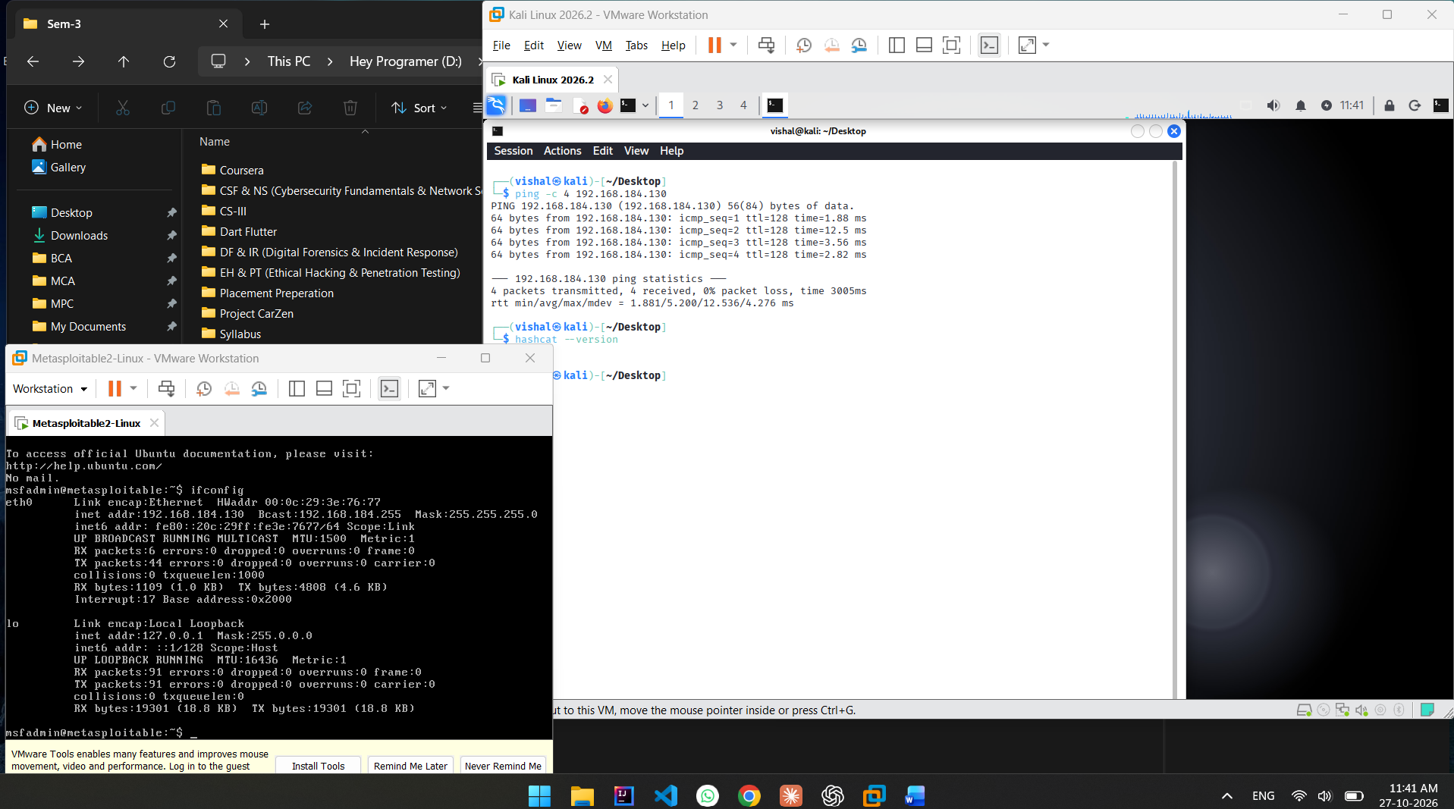
Figure 1:Successful ping and Metasploitable running

Poc Explanation:

Here Screenshot showing Metasploitable ip is 192.168.184.130And kali terminal showing ping command with 0% packet loss. This confirmed network connectivity between Kali Linux and the target machine.

Step 2: Access DVWA and configure security level low

Open Firefox and hit metsaploitable ip: 192.168.184.130/
Then click dvwa.
Login DVWA by default creadentials:
username: admin
password: password

After logging in, DVWA Security page was opened. Here click on DVWA security and set security level ‘Low’.

PoC:
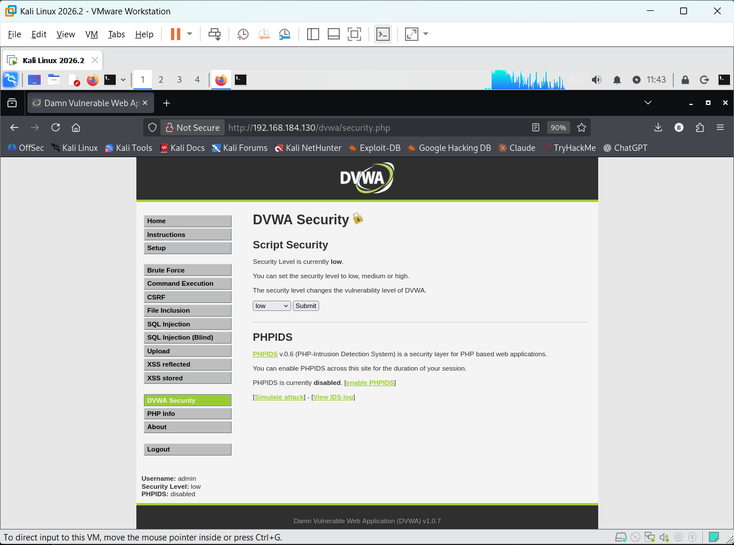
Figure 2: DVWA Security page showing Low security level.
POC Explanation:
Here screenshot showing DVWA security page. And security level is ‘Low’

Step 3: Test the SQL Injection module

Now click on SQL injection page. page contained a User ID input field and a Submit button.
Enter 1 and click Submit

PoC:
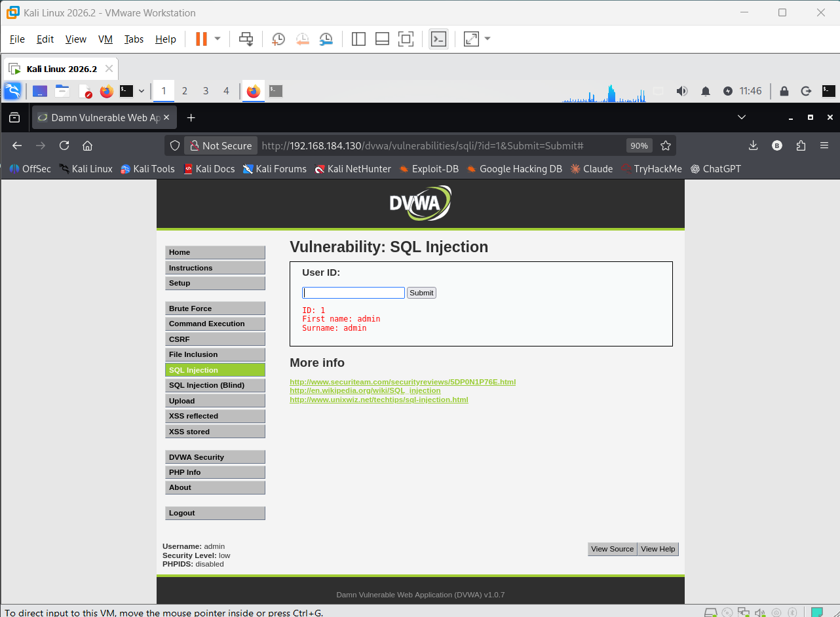
Figure 3:Normal SQL Injection module response for User ID 1.

POC Explanation:
Here screebshot showing normal dvwa page with filed enter 1 and get result:
- ID: 1
- First name: admin
- Surname: admin

Established the expected application behavior before testing the vulnerability.

Step 4: SQL Injection

Now in User ID field Enter actual SQL Injection Query command and click submit
Here I am Enter: 1’ UNION SELECT user, password FROM users-- -

Observation: The application returned records beyond the single user originally requested. This demonstrated that user-controlled input could alter the SQL query and disclose sensitive database information.
The password values displayed were hashes, not plaintext passwords.

PoC:
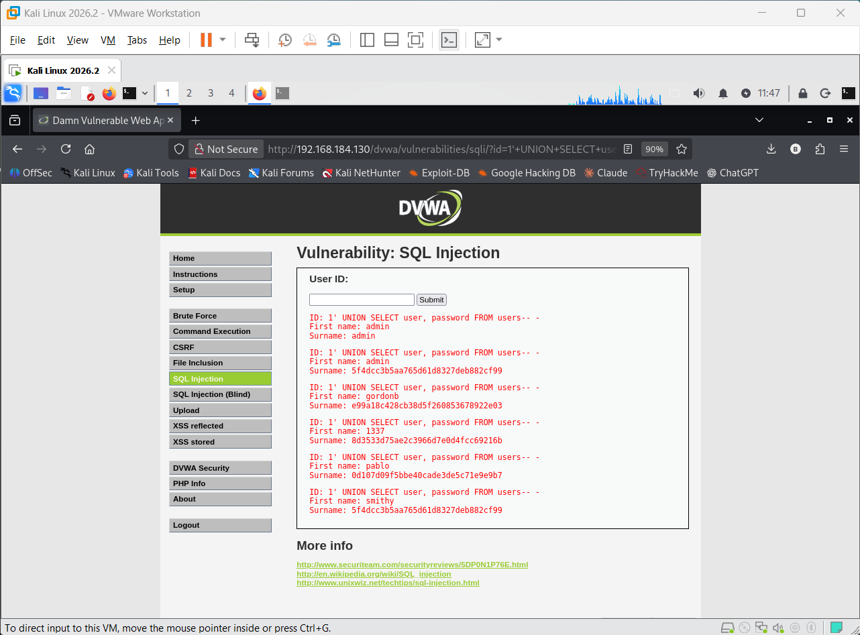
Figure 4:UNION-based SQL Injection returning multiple usernames and password hashes.
POC Explanation:
Here by submit 1’ UNION SELECT user, password FROM users-- - then result is showing all avalible users.
With it’s username and password’s (hashed)

Here ID: 1
First name: admin
Password: 5f4dcc3b5aa765d61d8327deb882cf99

Step 5: Save the recovered hash

The hash associated with the admin account was copied from the lab output into a local text file named admin_hash.txt.

The file was checked using: cat admin_hash.txt
The recovered hash was: 5f4dcc3b5aa765d61d8327deb882cf99

PoC:
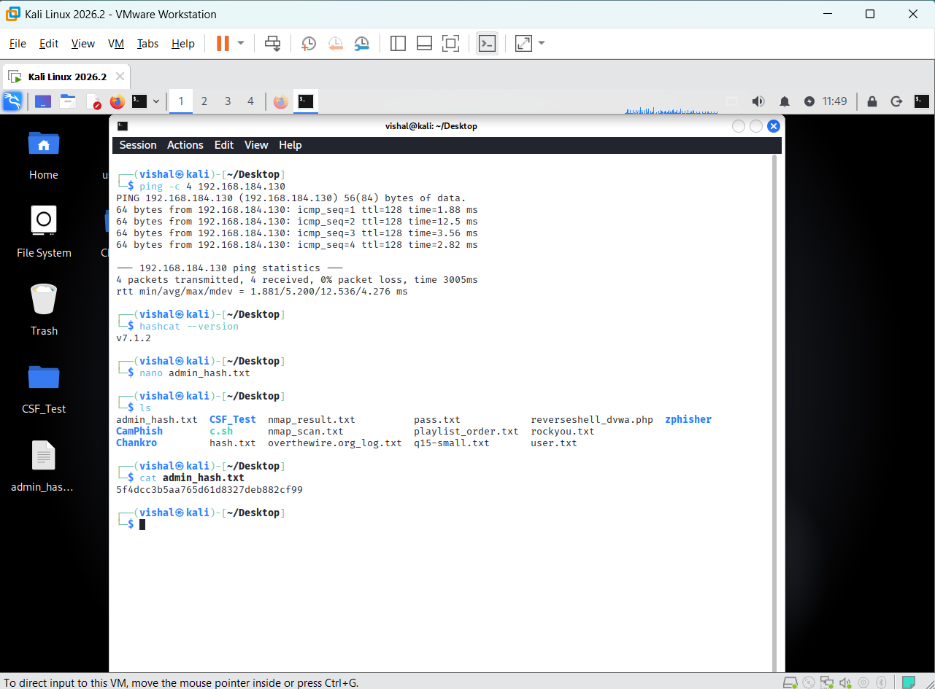
Figure 5: Local hash file and its contents in Kali Linux.
POC:
Here Screenshot showing hashcat version : v7.1.2
Then created txt file by nano command: nano admin_hash.txt and enter hash and save it.
Cat command showing file content that have hash: 5f4dcc3b5aa765d61d8327deb882cf99

Step 6: Crack hash using Hashcat

A dictionary-based password recovery attempt was conducted against the locally saved lab hash using the rockyou.txt wordlist.
The command shown in the evidence was:
hashcat -m 0 -a 0 admin_hash.txt rockyou.txt
Explanation of the command:

Argument | Meaning
hashcat | Starts Hashcat
-m 0 | Selects the raw MD5 hash mode
-a 0 | Selects dictionary attack mode
admin_hash.txt | File containing the hash
rockyou.txt | Candidate-password wordlist

PoC:
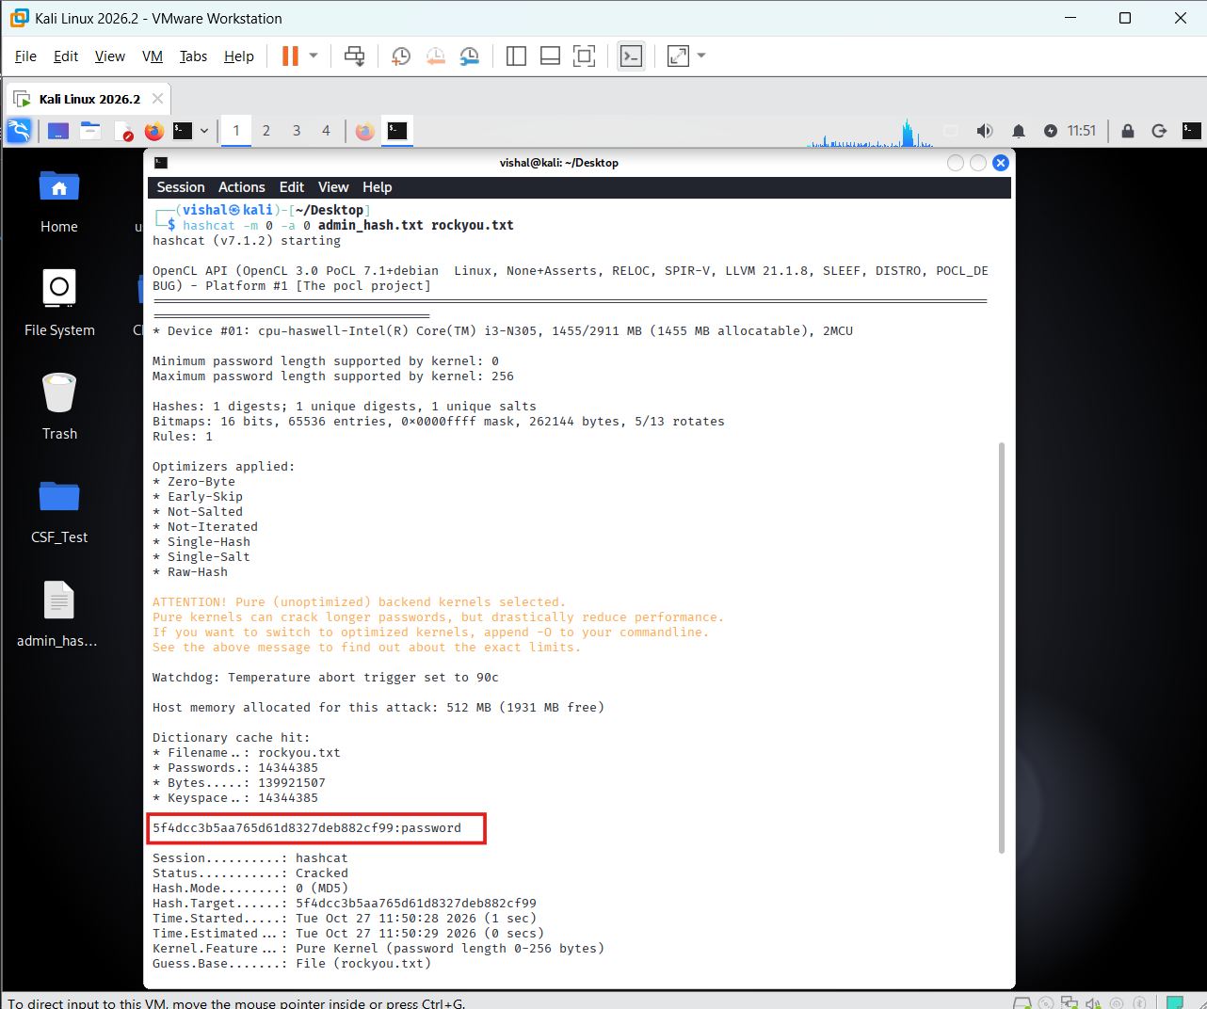
Figure 6: Hashcat output showing the recovered candidate and Status: Cracked.
POC Explanatin:
Hashcat reported the status Cracked and displayed the recovered candidate:
5f4dcc3b5aa765d61d8327deb882cf99:password

Step 7: CVSS Score

Open site chandabn.github.io/cvss/

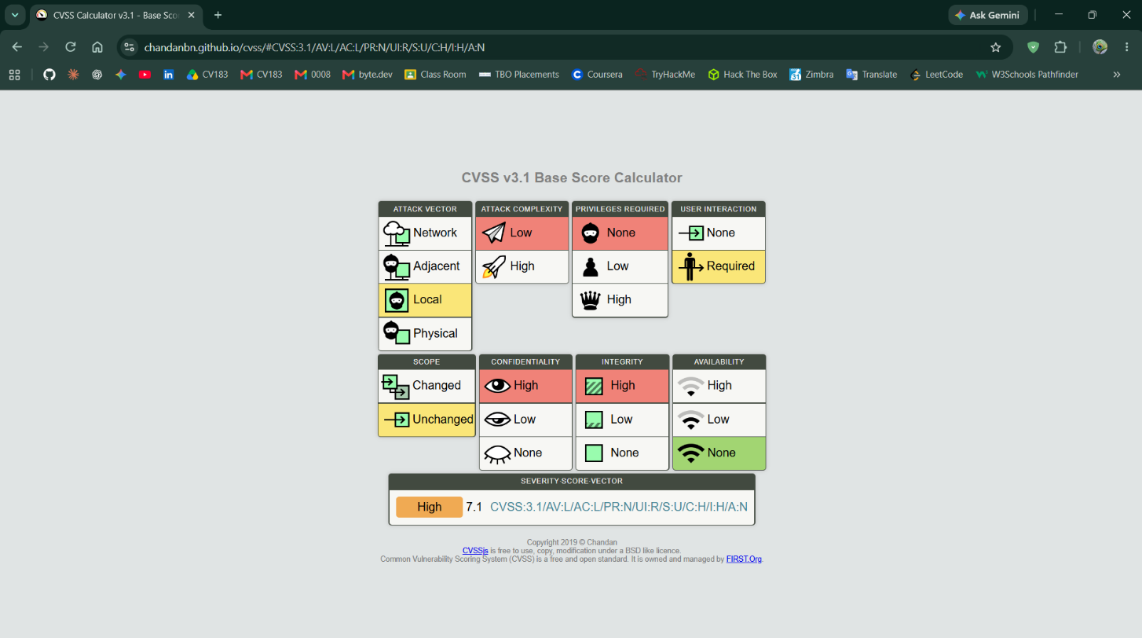
POC:
Here screenshot showing CVSS Score is High: 7.1

Conclusion

The SQL Injection practical demonstrated how insufficient handling of user-supplied input can allow an attacker to manipulate a database query and disclose sensitive information. The successful retrieval of multiple user records showed that the vulnerability extended beyond the intended single-record lookup. Subsequent dictionary-based recovery of a weak MD5 password hash demonstrated how exposed credentials can create an additional security risk.

Prevention:
1. Use prepared statements and parameterized queries
2. Validate input using allow-lists
3. Apply least-privilege database permissions
4. Store passwords using a suitable password-hashing algorithm
5. Secure error handling, monitoring, and testing

*** END OF ANSWERSHEET ***

